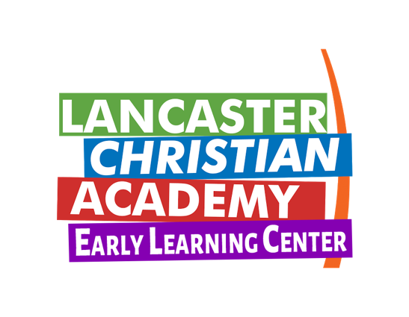

LCA K5R Supply List

16 Count Crayola Crayons
4 Glue Sticks
1 Bottle of Glue
Construction Paper
2 Boxes of Kleenex
1 Bottle of Germ-X
1 Can of Disinfectant Spray
1 Pair of Blunt Scissors
1 Pack of Crayola Washable Markers
1 Watercolor Paint Set

*Please turn supplies in to your child’s teacher by:
Monday, August 15th

